
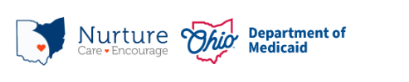

PRAF 2.0 NurtureOhio Interface:
Community Based Organizations
User Gue

Contents
Welcome New Users! 3
What is NurtureOhio? 3
NurtureOhio Features 3
Who Should Use NurtureOhio? 3
What is a PRAF? 4
What is an ROP? 4
Benefits of Using NurtureOhio to Submit Pregnancy Notifications: 4
User Types 4
How to Obtain Access to NurtureOhio as a first-time CBO User 5
How to Log into NurtureOhio 6
Forgotten Username or Password 7
NurtureOhio Initial Profile Setup 8
Welcome Screen 9
Updating User Information (the Edit User Profile Screen) 9
How to Submit a Report of Pregnancy (ROP) 11
Add Patient Information 11
Patient Validation 11
Patient Validation Fields 12
ROP Form 17
Referrals 19
Exporting 21
Exporting ROPs 21
Log Out 22
Help Desk and User Support 22
Help Form 22
Maintenance and System Outages 23
Appendix A 23
About NurtureOhio Features 23
Shareable Data Entry 23
Same-Day Pregnancy Notification 23
Ability to Retrieve and Save Previously Entered Forms 25

Welcome New Users!
This guide will help you navigate the NurtureOhio website. Some of the key items provided are:
- Definitions of Perinatal Risk Assessment Form (PRAF) and Report of Pregnancy (ROP) related topics
- Step by step guidance on getting access to and logging into the NurtureOhio system
- Step by step guidance on member referrals process
- Features of NurtureOhio
- Help with troubleshooting
- Additional tips and resources

What is NurtureOhio?
NurtureOhio was developed in 2016, in partnership with the Ohio Perinatal Quality Collaborative, the Ohio Department of Health, 23 Medicaid Maternal and Fetal Medicine providers, and the five Medicaid Managed Care Organizations (MCOs) to standardize pregnancy notification and decrease the risk of preterm birth. Through continued spread, the project has since grown beyond the progesterone quality improvement project, and the NurtureOhio web-based system has become the Ohio Department of Medicaid’s preferred method for notification of pregnancy and the postpartum period for all Medicaid-insured individuals across the state.

NurtureOhio is a web-based system that stores and shares information about perinatal risks and health-related social needs (HRSNs). This information is collected using the electronic Perinatal Risk Assessment Form (PRAF 2.0) and the Report of Pregnancy (ROP). Once a user submits either the PRAF 2.0 or ROP in NurtureOhio, the data is seamlessly transmitted to Ohio Medicaid’s eligibility system to ensure maintenance of Medicaid coverage, the Ohio Department of Health (ODH) for connection to the Women and Infant Nutrition Program (WIC), the Ohio Department of Children and Youth (DCY) for evidence-based Help Me Grow Home Visiting, and the individual’s County Department of Jobs and Family Services (CDJFS ) and Managed Care Organization (MCO) for resources and identified needs.

NurtureOhio is used to notify the Ohio Department of Medicaid and key stakeholders of pregnancy and the start of the postpartum period for all Medicaid-insured individuals for eligibility maintenance and care coordination. Through the PRAF and ROP, NurtureOhio transmits the minimum information needed about Medicaid individuals’ pregnancy and postpartum information to the appropriate stakeholders to ensure their needs are met.

NurtureOhio Features
- Shareable Data Entry
- One Time Data Entry of Practice and Provider Information
- Same-Day Pregnancy Notification
- Ability to Retrieve and Save Previously Entered Forms
- Ability to Export CSV files of submitted PRAFs and ROPs
More information on these features can be found in Appendix A.

Who Should Use NurtureOhio?
- Clinical obstetrical providers should submit a Perinatal Risk Assessment Form (PRAF) on behalf of their patients at the first prenatal appointment, or when a patient’s risks change in the prenatal or postpartum period.
- Clinical non-obstetrical providers, such as primary care providers, emergency department providers, local health department clinics, etc. should submit a Report of Pregnancy (ROP) at the first report of pregnancy.
- Community Based Organizations (CBO) and Managed Care Organizations (MCO) should also submit an ROP at the first report of pregnancy.
- Managed Care Organizations (MCOs) and County Department of Jobs and Family Services (CDJFS) to assist with resource connection.

What is a PRAF?
The Perinatal Risk Assessment Form (PRAF) is an assessment that is intended for completion and submission by all obstetrical providers at the Medicaid patient's first prenatal visit, the start of the postpartum period, and whenever there are changes in the patient's perinatal medical, social risk factors or needs. The PRAF collects perinatal risk and health-related social needs. PRAF replaces the ODM 03535 form. The web-based version of the Perinatal Risk Assessment (PRAF 2.0) is ODM’s preferred method for submission.

What is an ROP?
The purpose of the Report of Pregnancy (ROP) form is to capture a Medicaid individual’s pregnancy as soon as possible to assist with eligibility and care coordination. ROPs are intended for submission at the first identification of a positive pregnancy. This may occur in primary care practice, at the emergency department, or within a local health clinic. For example, if a patient is seen at the emergency department or a local health department and is determined to be pregnant, an ROP should be submitted on behalf of the patient. The goal is to connect the individual to obstetrical care and other services and ensure coverage throughout pregnancy and the postpartum period to optimize health care access and health outcomes for the mother and infant. Again, the ROP is only intended for submission by non-obstetrical Medicaid providers, Medicaid MCOs, Doulas, and CBOs.

Benefits of Using NurtureOhio to Submit Pregnancy Notifications:
- Updating pregnancy details in Ohio’s Medicaid Eligibility System to prevent loss of Medicaid coverage during pregnancy and postpartum period.
- MCO notification of potential members for care coordination and incentive programs to provide support and resources during pregnancy and the postpartum period.
- Enables County Department of Job and Family Services (CDJFS) users to verify that pregnancies are added to the Ohio Benefits system and coordinate care via referrals.
- Timely referrals to the Ohio Department of Health’s (ODH) Special Supplemental Nutrition Program for Women, Infants, and Children (WIC).
- Referrals to The Ohio Department of Children and Youth’s (DCY) Help Me Grow Home Visiting Central Intake platform.

User Types
Users are classified into six different user types which impact what views they have access to and how they enter information in the NurtureOhio system. For the purposes of NurtureOhio, ODM defines the following user types:
- Practice users as those users associated with a practice that provides obstetric services.
- MCOs as those users affiliated with ODM’s contracted Managed Care Organizations.
- Non-OBGYN are users associated with a clinical practice that does not provide obstetric services but can confirm an individual’s pregnancy via a positive pregnancy screening such as primary care, emergency department, urgent care, community health centers, community clinics, etc., and as those users identified by ODM as doulas.
- Secondary MCOs as those users affiliated with ODMs contracted Managed Care Organizations as secondary MCOs.
- OEI Community Based Organizations (CBO) and CBO Lead Entities as those users from organizations identified by the Ohio Department of Medicaid as Ohio Equity Institute Lead Infant Mortality Entities and their corresponding Community Based Organizations.
- County Department of Job and Family Services Healthchek/PRS workers as those users specializing in pregnancy related services for CDJFS office.

How to Obtain Access to NurtureOhio as a first-time CBO User
- CBOs must designate a lead individual to submit requests for new users using the NurtureOhio Microsoft Access Request Form. The link to the form can be obtained by sending a request to MomsAndBabies@medicaid.ohio.gov.
- The lead will complete the Microsoft form and submit it.
- Once the new user is added, the lead and the new user will be notified via email.
- When the new user logs into NurtureOhio for the first time, they will need to choose “Internal” from the dropdown box, enter their email as the username and then click “Forgot Password?” to set up their password for the first time.
- The system will send a password reset to the user's email; the user should check the spam folder for the email if it is not in their main folder.

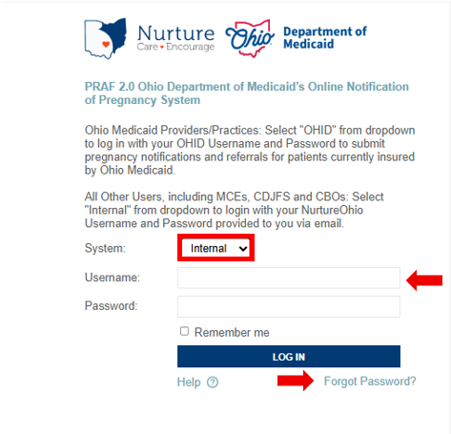

How to Log into NurtureOhio
To access, visit the NurtureOhio website
- Select "Internal" from the dropdown list, then enter your Username and Password. Click “LOG IN.”
- Logging in allows all CBO users to submit Reports of Pregnancy for patients currently insured by Ohio Medicaid.
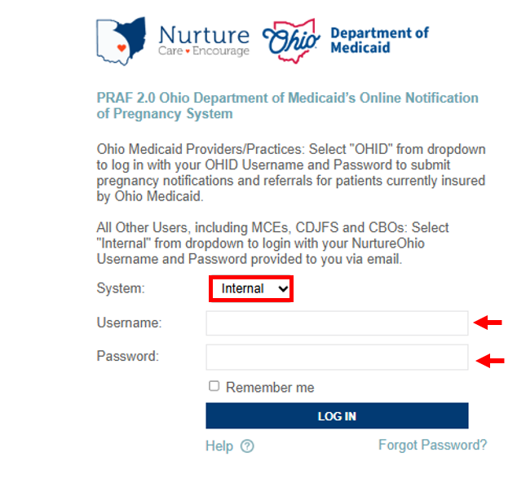

Forgotten Username or Password
If you need help logging in, contact nurtureohiosupport@deliverhealth.com.
If you have forgotten your username or password, select ‘Forgot Password?’ and enter the email associated with your user account.
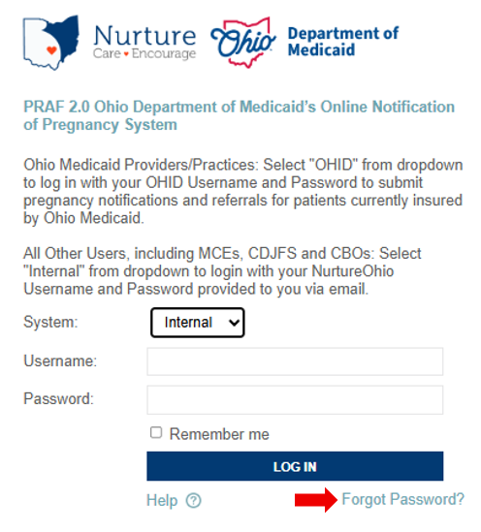

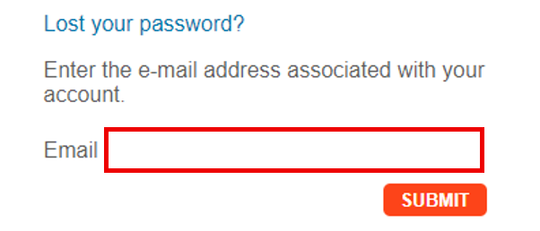

NurtureOhio Initial Profile Setup
After logging into NurtureOhio for the first time, users will be taken to “New User Profile Setup” page. Here users can update their password to something more memorable.
Once the user has updated their password, click “SAVE & BEGIN.” The user will be redirected to their welcome screen.
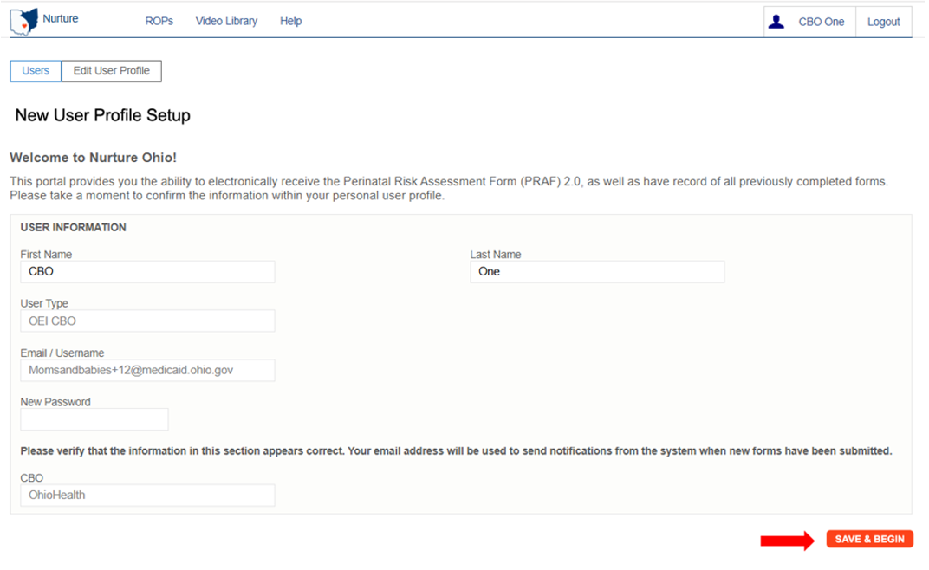

Welcome Screen
After logging in, CBO users will be taken to the Welcome Screen. The Welcome screen allows users to perform or access multiple tasks, including:
- Updating user information by clicking on the User ID
- Viewing submitted ROPs
- Searching for existing forms using any of the following:
  - Patient Name
  - Patient DOB
  - Patient Medicaid transmission status
  - Date of Creation (Specific date or date range)
  - Date of Service (Specific date or date range)
- Viewing organization notifications
- Access to information needed to complete reports
- Downloading completed forms in PDF format or patient information in CSV format
- Exporting multiple forms at once to a CSV file
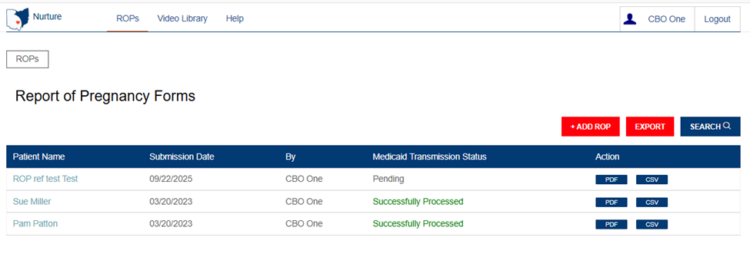

Updating User Information (the Edit User Profile Screen)
After clicking on the User ID on the Welcome Screen, users can edit information about their user account. On this screen, users can:
- Edit first name and last name
- Change their password
- View user type
- Click the “Save” button to save any changes and return to the Welcome Screen. If no changes have been made, click the “Users” button at the top left of the screen
Note: Some information associated with your User ID will be inserted automatically. You will not be able to edit this information. Contact your lead to submit edits, if needed, for prepopulated information.
Be sure to click the “Save” button at the bottom of this screen to save any changes you make, or they will be lost.

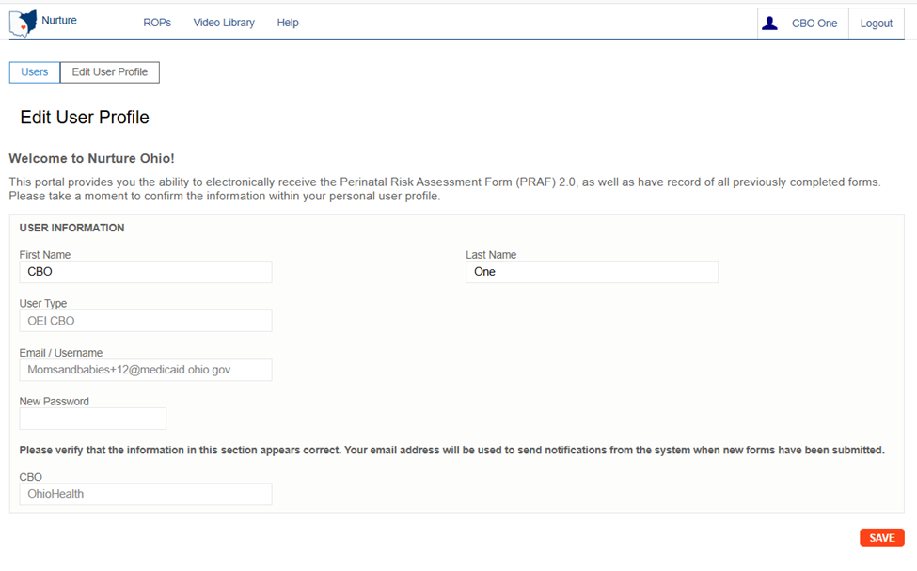

How to Submit a Report of Pregnancy (ROP)
From the welcome page, the user will choose the “ROPs” tab
After clicking the “+ ADD ROP” button on the main ROP screen, users can begin entering information.

Add Patient Information

Patient Validation
To improve data quality and ensure HIPAA protections, a patient validation feature has been added to check that the information entered is linked to an individual’s Medicaid case. To complete this validation, NurtureOhio takes the information entered and searches against Ohio Medicaid’s eligibility system. The user will then receive feedback based on the data entered. If the information does not match, the user will have the opportunity to correct, re-validate, and resubmit. If the information still does not match after correcting the indicated fields, the user may continue without validation but will need to verify the data after submission, complete any necessary edits to the ROP, and then resubmit. The user has up to 30 days to edit the form and resubmit. After 30 days, the user cannot edit a form and must submit a new one.

Patient Validation Fields

1. Complete the required fields:
- Patient First Name
- Patient Last Name
- Estimated Due Date
- Patient DOB
- Patient Medicaid ID (MMIS number) and/or Patient Social Security Number (9-Digit)
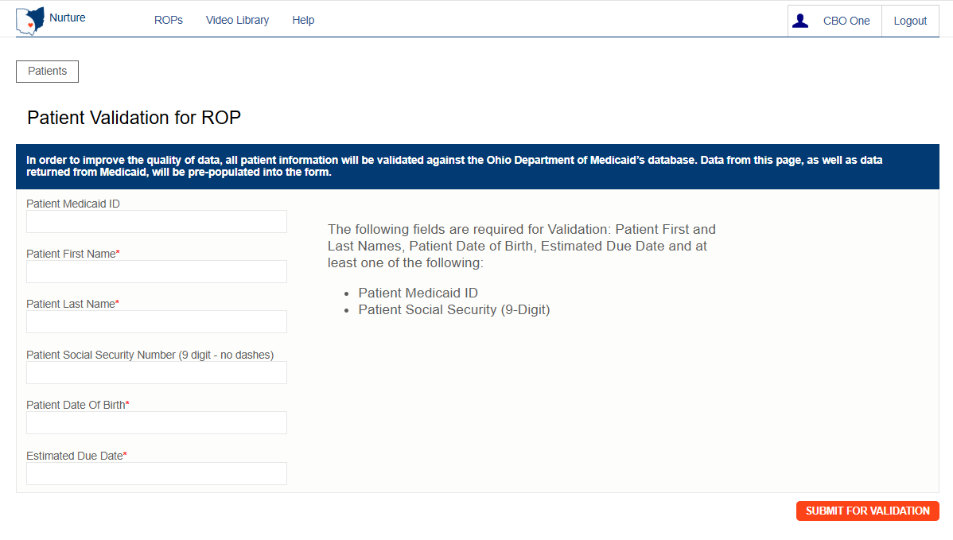
Note: The Patient's Medicaid ID may be found on the Medicaid card as shown in the graphic below. For more information and to view the Medicaid ID on archived Medicaid cards, see Appendix A.

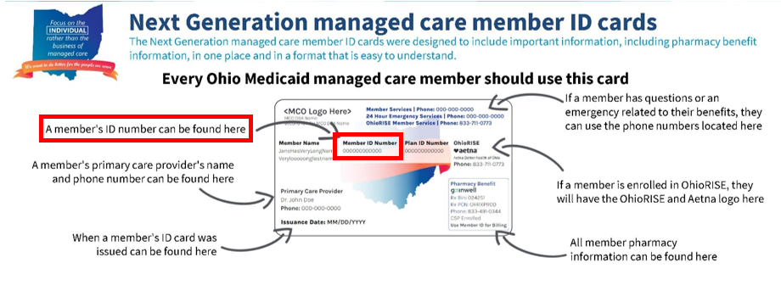

2. Select “Submit for validation”
- NurtureOhio will search the ROP system to ensure no other records from the last 30 days can be found in the system for that member.

The following notification appears when you submit, select OK to proceed
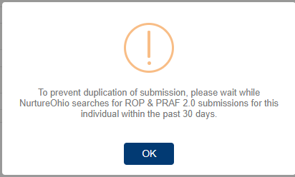
The following notification will appear if you are missing the required information
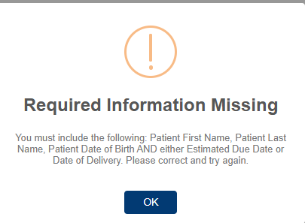
The following notification will appear when no matching ROP record is found:
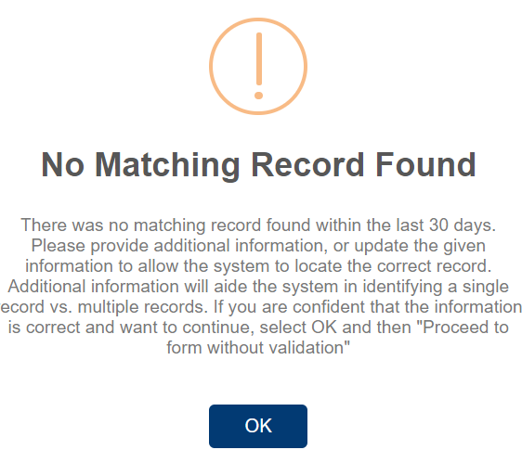

The following notification will appear when a matching record is found:
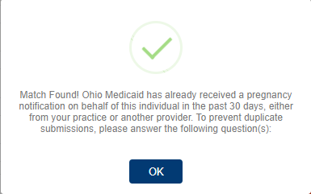

If a matching record is found, users must then answer the following questions:
In the past 30 days, have there been changes to:
- The individual’s health?
- Social risk factors from the prior submission?
  - If yes: the user may continue to complete a new form.
  - If no: the user must open the previously completed form to edit with new information, or the user can stop the submission.

In the screenshot below, the red, circled X indicates that the information provided does not have a matching record in the Medicaid system and needs to be addressed.
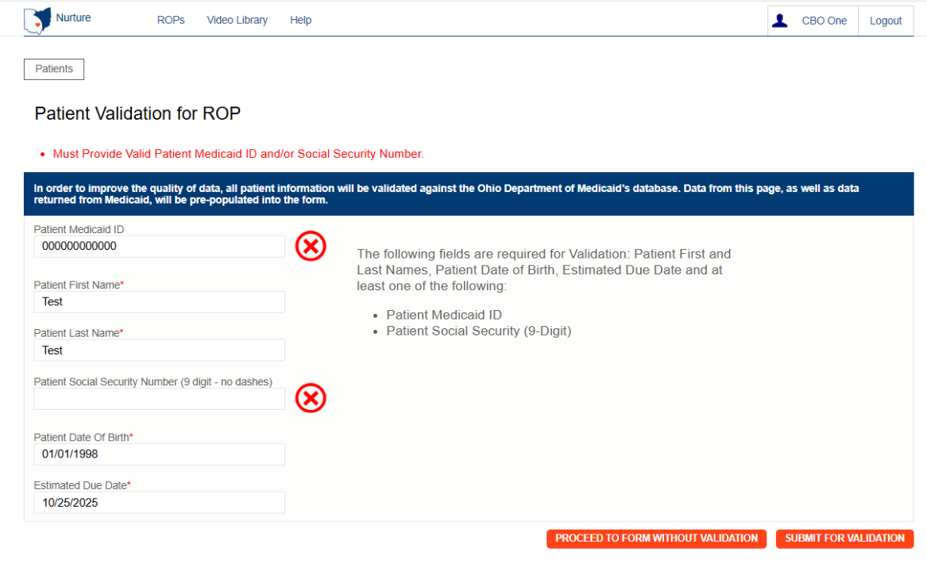

There can be multiple errors returned at once and NurtureOhio does its best to identify the fields that need to be addressed. The common errors that can be returned are as follows:

- Invalid/Missing Date(s) of Service
- Patient Date of Birth Does Not Match the Patient on File
- Invalid/Missing Patient Medicaid ID
- Invalid/Missing Patient Name
- Patient Not Found
- Duplicate Patient ID Number
- Must Provide Valid Patient Medicaid ID and/or Social Security Number
- Patient does not have active Medicaid coverage
- System is unable to respond, please contact NurtureOhio Helpdesk (This error also sends an alert to NurtureOhio)

To proceed the user must:
- Verify the patient’s information.
- Correct errors
- Resubmit for validation

In the screenshot below, the green circled check mark indicates that the information provided has a matching Medicaid record and the user may proceed to the form.
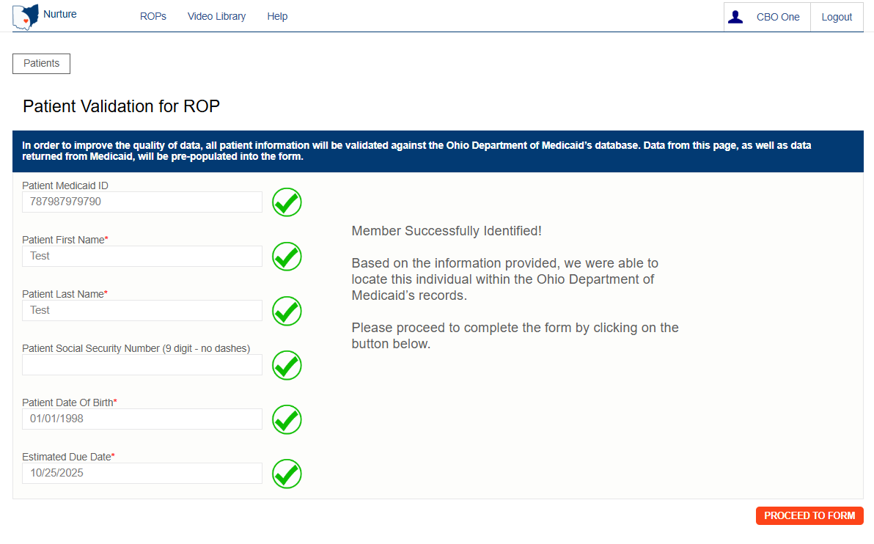

Note: The ROP can be submitted without verifying eligibility by selecting “Proceed to Form Without Verification” but please note the risks below:
- Potential HIPAA violation
- System not notified of Medicaid eligibility

ROP Form
After clicking the “Proceed to Form” button, users are directed to the ROP Form (shown over the next few pages).
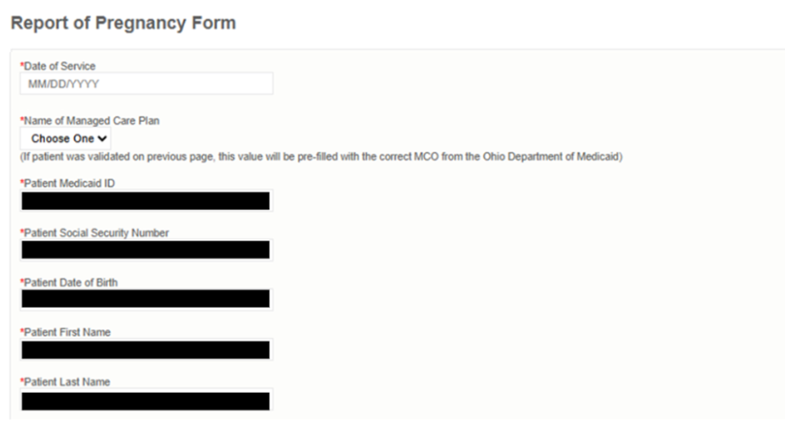

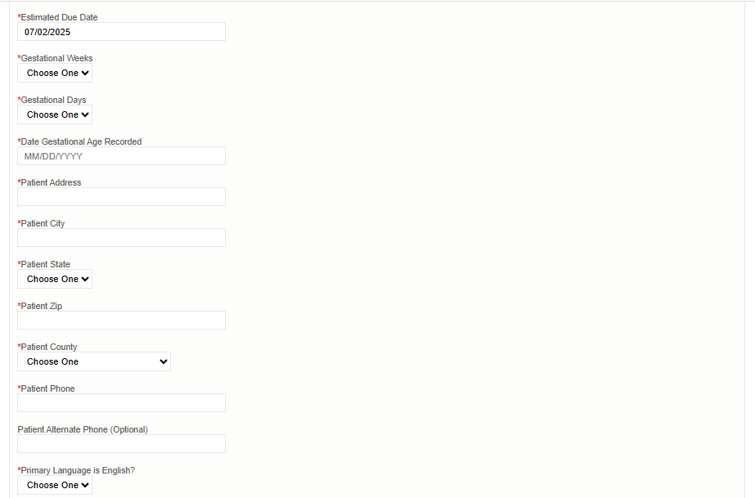

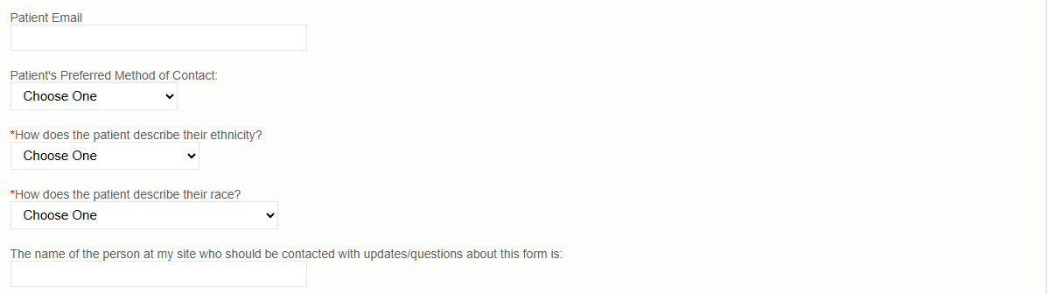

Referrals
This section is where submitters are asked to identify specific patient needs. Selecting a need will automatically trigger a referral to the patient’s Managed Care Organization (MCO) and County Department of Job and Family Services (CDJFS).
Patient need options include: Transportation; Food; Housing; Utilities; and Assistance finding an OB/GYN provider.
Submitters are prompted to indicate whether the patient:
- Assistance scheduling appointments (Yes/No)
- Patient has a prenatal appointment scheduled (Yes/No)
This information helps MCO and CDJFS staff provide appropriate support.
Submitters are prompted to indicate if the patient should be referred to WIC and/or Help Me Grow Home Visiting.
- Once the ROP is submitted, the Ohio Department of Health and the Department of Children and Youth are automatically notified if these resources are selected.

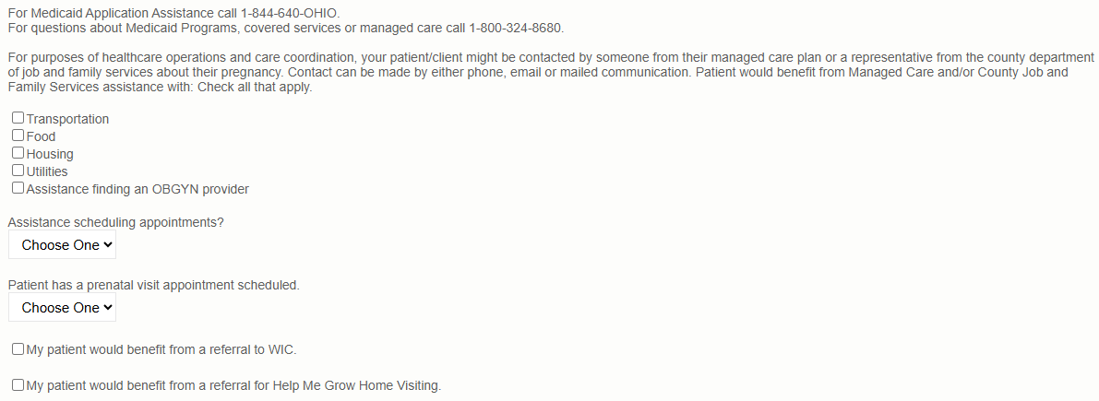
Checking “My patient would benefit from a referral to WIC” or “My patient would benefit from a referral for Help Me Grow Home Visiting” will prompt you for permission to text the patient. You must ensure you have a cell phone listed for either the patient’s primary or alternate phone number listed on the form.
Once all required sections have been completed, click the “Submit” button.
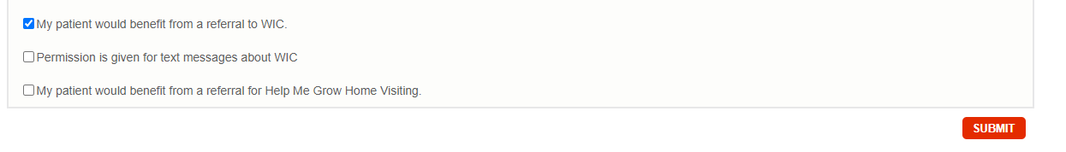
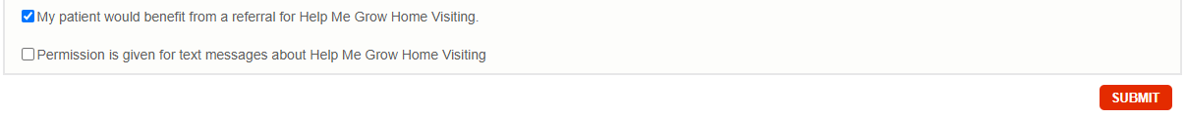
Make sure you see the “Form Completed!” message
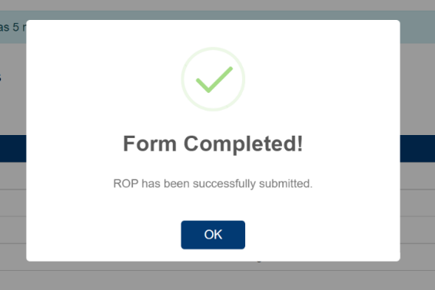

Note: If required areas are missing from the document, the user will be directed to those areas for correction or addition of information. Missing information is outlined in red.

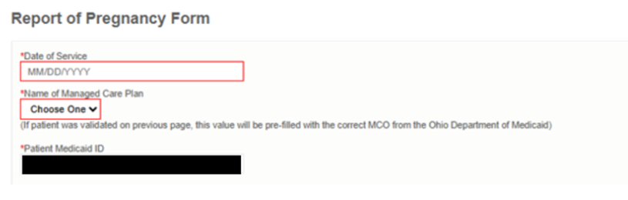

After the ROP form is submitted, it will appear on the homepage.
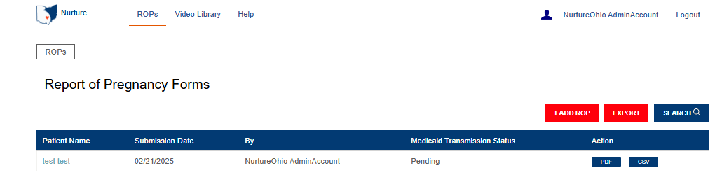

Note: CBO users can view both the ROPs they submitted themselves and any ROPs submitted by other users associated with the same CBO.

If you have any general questions regarding the ROP form content or process, please email MomsandBabies@medicaid.ohio.gov with the subject ‘ROP Form’.

Exporting

Exporting ROPs
The Export option allows you to export all forms associated with the logged-in CBO user to a CSV file.
Click the Export button next to the search button.
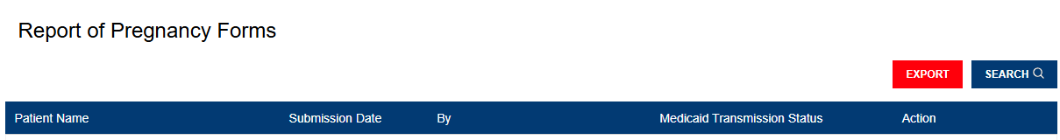

The dropdown menu will provide you with the export option for ROPs. The file will be exported and saved to the default download folder on your local machine.
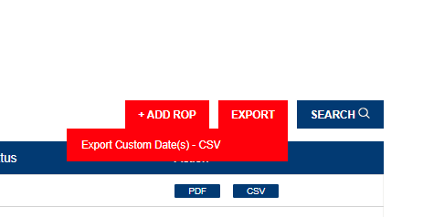

Log Out
It is important to log out of the NurtureOhio system when finished.
- Select “Logout” in the top right-hand corner of the screen.

Help Desk and User Support
If you have any concerns or issues with the website or are unable to view fields, please use the “Help” button shown in the screenshot below.

Help Form
You will then want to describe the issue that you are experiencing in the text box. Include a contact email and then click ‘Submit.
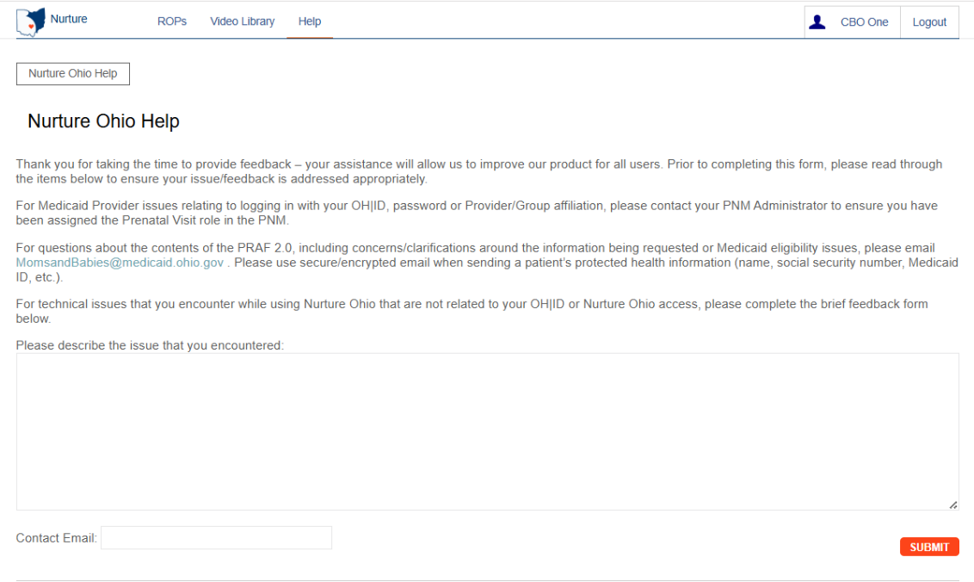

Maintenance and System Outages
If the NurtureOhio system is shut down for maintenance, you will receive an e-mail from the Nurture Helpdesk (no-reply@duethealth.com). The Ohio Department of Medicaid paper-based notification process can be used during these system outages. The paper-based form, ODM 102577, and its accompanying instructions, ODM 102577, can be found at the Medicaid website Resources page.

Appendix A

About NurtureOhio Features

Shareable Data Entry
Users can edit a ROP form submitted by another CBO user up to 30 days after the original submission date.

Same-Day Pregnancy Notification
Pregnancy notification helps patients maintain Medicaid eligibility. It also helps MCOs and CDJFS to address the needs of pregnant Medicaid members more quickly.
The NurtureOhio website can notify the managed care plan and the Ohio Benefits Worker Portal of the patient’s pregnancy the same day it is entered into NurtureOhio. Practice users assist in this process by accurately entering the following patient information:
- First name
- Last name
- Date of birth
- Social security number (full nine digits)
- Medicaid ID/MCID
Ohio Benefits, Medicaid’s eligibility system, accepts pregnancy information directly from the information users enter in NurtureOhio. Accuracy of the five details above is important to match the individual’s case in Ohio Benefits. The member ID as displayed on the patient’s Medicaid card and/or the patient’s social security number is important as they are used to identify the member for whom pregnancy needs to be updated. The estimated pregnancy due date paired with the latter five identifiers are used to update the Ohio Benefits system. This helps prevent loss of coverage during pregnancy.
Please note the member ID number is consistent across Medicaid MCOs; however, the member ID number will not always be the same as the MCO ID #, which varies by insurance plan. Thus, please be sure to capture the member ID number and not mistakenly input the MCO ID #.
The member ID # is:
  - Used to verify a patient’s eligibility and their MCO,
  - Consistent across all MCOs and Ohio Medicaid, and
  - Required for the PRAF 2.0 form to communicate with Ohio Benefits.
Below is where you will locate the member ID number on our contracted managed care entity insurance cards.
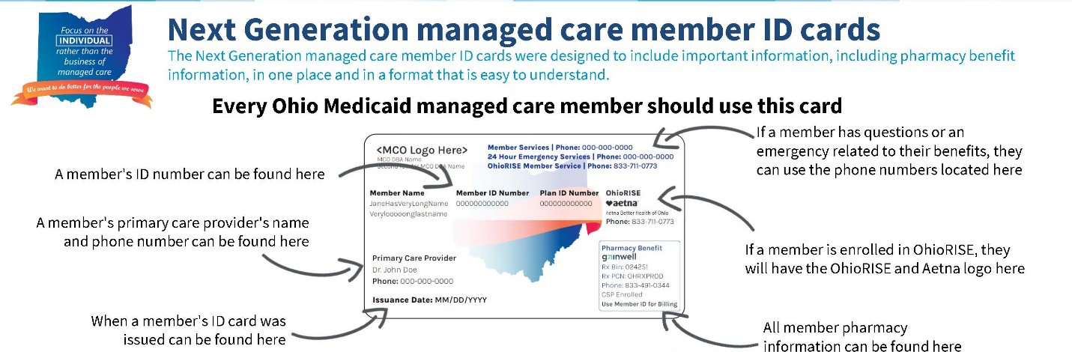

Below is where you will locate the member ID number on archived versions of the managed care organization cards.


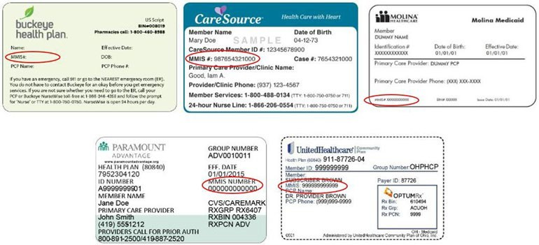

Ability to Retrieve and Save Previously Entered Forms
Forms entered can be viewed and downloaded in two different formats (PDF and CSV).
- Navigate to the “ROP” tab
- Select the ROP you want to retrieve or save
- After making your selection you can choose PDF or CSV under the Action heading to view or
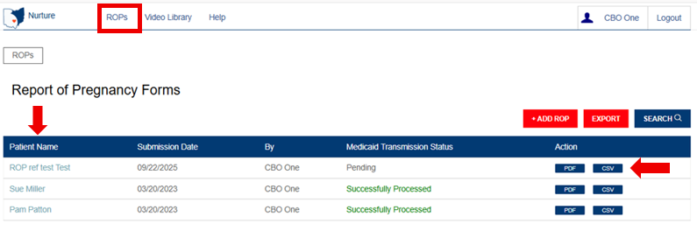
download for.

